FOR IMMEDIATE RELEASE

Contact: Shields B. Howard
Development & Marketing Manager
Hospice of Stanly & the Uwharrie
704.983.4216 ext. 114
showard@hospiceofstanly.org

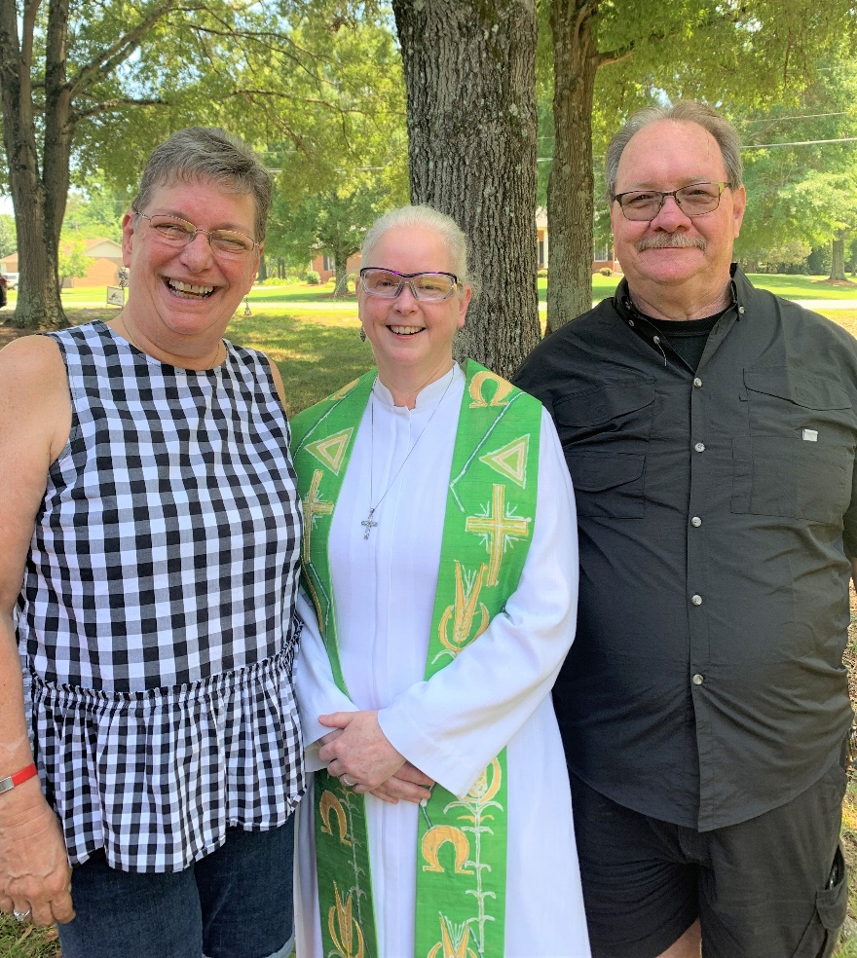
Mr. & Mrs. Thomas E. Brattain with Karen Kaser-Odor, M. Div.

Wedding Bells Ring for Hospice of Stanly

July 8, 2022 (ALBEMARLE, NC) – Typically not part of their practice, wedding bells rang recently for Hospice of Stanly. Melody Measimer and Thomas E. Brattain were wed at the home of Melody’s mother, Eva Clark. Mrs. Clark is a patient of Hospice of Stanly.

“If I can’t bring mother to the wedding, I’ll bring the wedding to her!” said the joyous bride of the home wedding.

The groom, Tom Brattain, is a cross-country truck driver who will soon be leaving on an extended haul for nearly 3 months. “It was important to Melody for her mother to witness the ceremony,” he said. “We wanted her to know that Melody will have a partner. We’ll take care of each other.”

“We thank Hospice of Stanly for helping with the wedding today,” said Melody Brattain. “This organization has helped our family immeasurably – with support and taking care of mother as well as training and education on her condition.”

Mrs. Clark’s Certified Nursing Assistant, Wendy Springer of Hospice of Stanly served as a witness to the happy occasion and the wedding was officiated by the organization’s Chaplain, Karen Kaser-Odor, M. Div.

“This was a very special wedding for me,” said Kaser-Odor. “It was a real gift to be able to sing Mrs. Clark’s favorite hymn with the bride and groom during the ceremony.”

If you would like more information about hospice services, please visit hospiceofstanly.org or call 704.983.4216.

About Hospice of Stanly & the Uwharrie
Hospice of Stanly & the Uwharrie, a nonprofit organization, was founded through the grassroots efforts of people in the community and it continues to be governed locally by a board of directors. Through the generosity of many, Hospice of Stanly has been able to provide care to nearly 7,000 seriously ill residents since 1981. The organization provides compassionate care, comfort, and support for patients and their families. More information about hospice and advance care planning is available from Hospice of Stanly & the Uwharrie by calling 704.983.4216 or by visiting hospiceofstanly.org.

###

