FOR IMMEDIATE RELEASE

Contact: Shields B. Howard
Development & Marketing Manager
Hospice of Stanly & the Uwharrie
704.983.4216 ext. 114
showard@hospiceofstanly.org

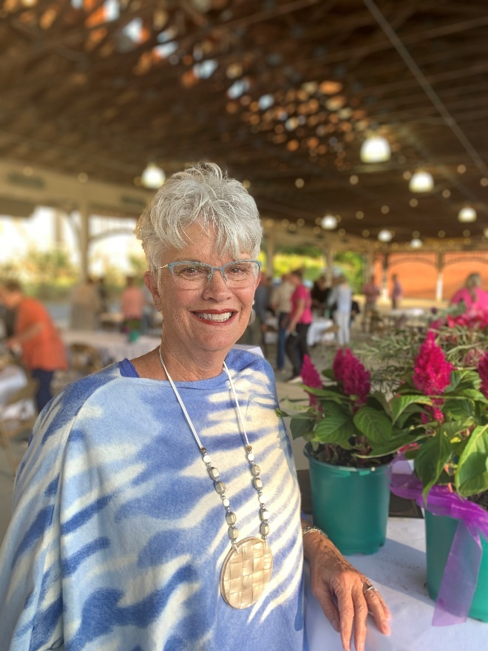
Lou Page was awarded the Hospice of Stanly Volunteer Lifetime Achievement Award

Hospice of Stanly Awards Volunteer Lifetime Achievement Honor

ALBEMARLE, NC (May 18, 2022) - Hospice of Stanly awarded Lou Page of Norwood the Volunteer Lifetime Achievement honor at a volunteer dinner and recognition event held recently. Lou has donated more than 1,000 hours of her time to Hospice of Stanly to help fulfill their mission to surround patients and their families with compassionate care, enabling them to embrace the end of life with dignity, courage, and peace.

“Lou has been a valued volunteer for Hospice since 2013,” said Executive Director Lori Thayer. “She has a helpful attitude and a pleasant personality that our staff and patients enjoy.”

“About a year after I lost my husband Ronnie, I knew I wanted to be part of the wonderful ministry provided by Hospice of Stanly. I love making calls, helping with special events, and spending time with our patients,” said Page.

Lou Page has been involved with direct patient care, calls to patients, donor appreciation calls, fundraising events, and much more. She completed the required initial volunteer training and has maintained the annual service hours and education hours also required by the Centers for Medicare/Medicaid Services.

Volunteer Coordinator Hailey Black said, “Lou is an exceptional person and an exceptional volunteer. She has enriched the care we provide by offering a reassuring presence and a friendly smile to our patients and their families.”

In addition to the Lifetime Achievement Award, the organization also recognized Pam Holbrook for the overall hours she has volunteered with the organization; Sharon Covey received recognition for total and administrative hours in 2021; Debbie Kiker was recognized for the number of hours she served in direct patient care; and Jo Ann Bowers was awarded for her hours in fundraising events for Hospice of Stanly.

Other volunteers were recognized for their years of service to the organization.
- 25 years – Pat Mills
- 15 years – Sarah Lee
- 10 years – Betty Andrews, Maxine Basinger, and Bob Johnson
- 5 years – Debbie Carter and Lynnie Lawrence

If you would like more information about becoming a Hospice of Stanly volunteer or to make a donation to Hospice of Stanly, please visit hospiceofstanly.org or call 704.983.4216.

About Hospice of Stanly
Hospice of Stanly, a nonprofit organization, was founded through the grassroots efforts of people in the community and it continues to be governed locally by a board of directors. Through the generosity of many, Hospice of Stanly has been able to provide care to nearly 7,000 terminally ill residents since 1981. The agency has begun offering palliative care, which helps patients manage the symptoms of serious but not life-threatening illness. The organization provides compassionate care, comfort, and support for patients and their families. More information about hospice and advance care planning is available from Hospice of Stanly by calling 704.983.4216 or by visiting hospiceofstanly.org.

###

