FOR IMMEDIATE RELEASE

Contact: Shields B. Howard
Development & Marketing Manager
Hospice of Stanly & the Uwharrie
704.983.4216 ext. 114
showard@hospiceofstanly.org

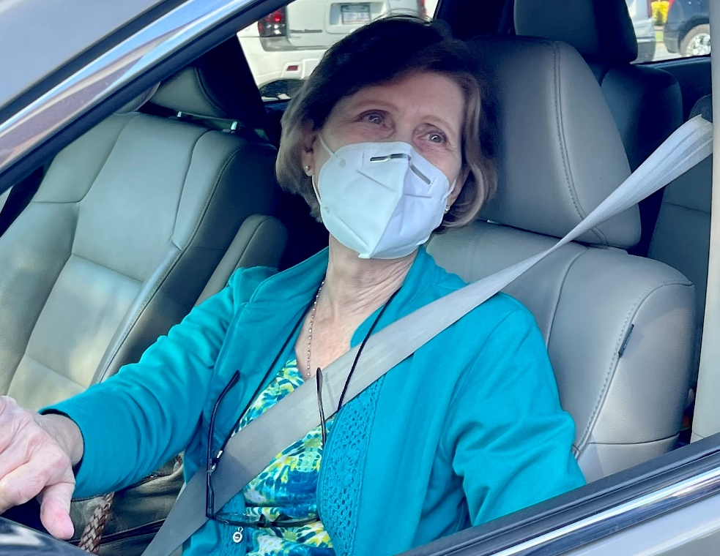
Hospice of Stanly & the Uwharrie Awards Volunteer Lifetime Achievement Honor

June 4, 2021 (ALBEMARLE, NC) - Hospice of Stanly & the Uwharrie awarded Pam Holbrook, of Albemarle, the Volunteer Lifetime Achievement Honor at a volunteer drive-through dinner and recognition event in April. Pam has donated more than 5,000 hours of her time to Hospice of Stanly & the Uwharrie to help fulfill their mission to surround patients and their families with compassionate care, enabling them to embrace the end of life with dignity, courage, and peace.

“We thank Pam for her service to Hospice of Stanly & the Uwharrie,” said Executive Director Lori Thayer. “She has been a faithful volunteer with our organization since March 1988 - a whopping 33 years! Her dedication has brought benefit to our patients and their families, our staff, and the entire community.”

Pam’s service to hospice has included patient visits, crafting angels for the annual hospice angel fundraiser, decorating for the Festival of Trees event, baking goodies for hospice events, staffing the Christmas shop, and participating in fundraising events. Pam also served as a member of the Board of Directors from October 1989 through December 1992.

“Pam has done it all, but she is more than a worker bee to us,” said Volunteer Coordinator Hailey Black. “She is a warm, caring individual and she spreads her positive attitude wherever she goes. She is a delight to our organization.”

If you would like more information about volunteering or to make a donation to Hospice of Stanly & the Uwharrie, please visit hospiceofstanly.org or call 704.983.4216.

About Hospice of Stanly & the Uwharrie
Hospice of Stanly & the Uwharrie, a nonprofit organization, was founded through the grassroots efforts of people in the community and it continues to be governed locally by a board of directors. Through the generosity of many, Hospice of Stanly has been able to provide care to more than 6,600 terminally ill residents since 1981. The organization provides compassionate care, comfort, and support for patients and their families. More information about hospice and advance care planning is available from Hospice of Stanly & the Uwharrie by calling 704.983.4216 or by visiting hospiceofstanly.org.

###

